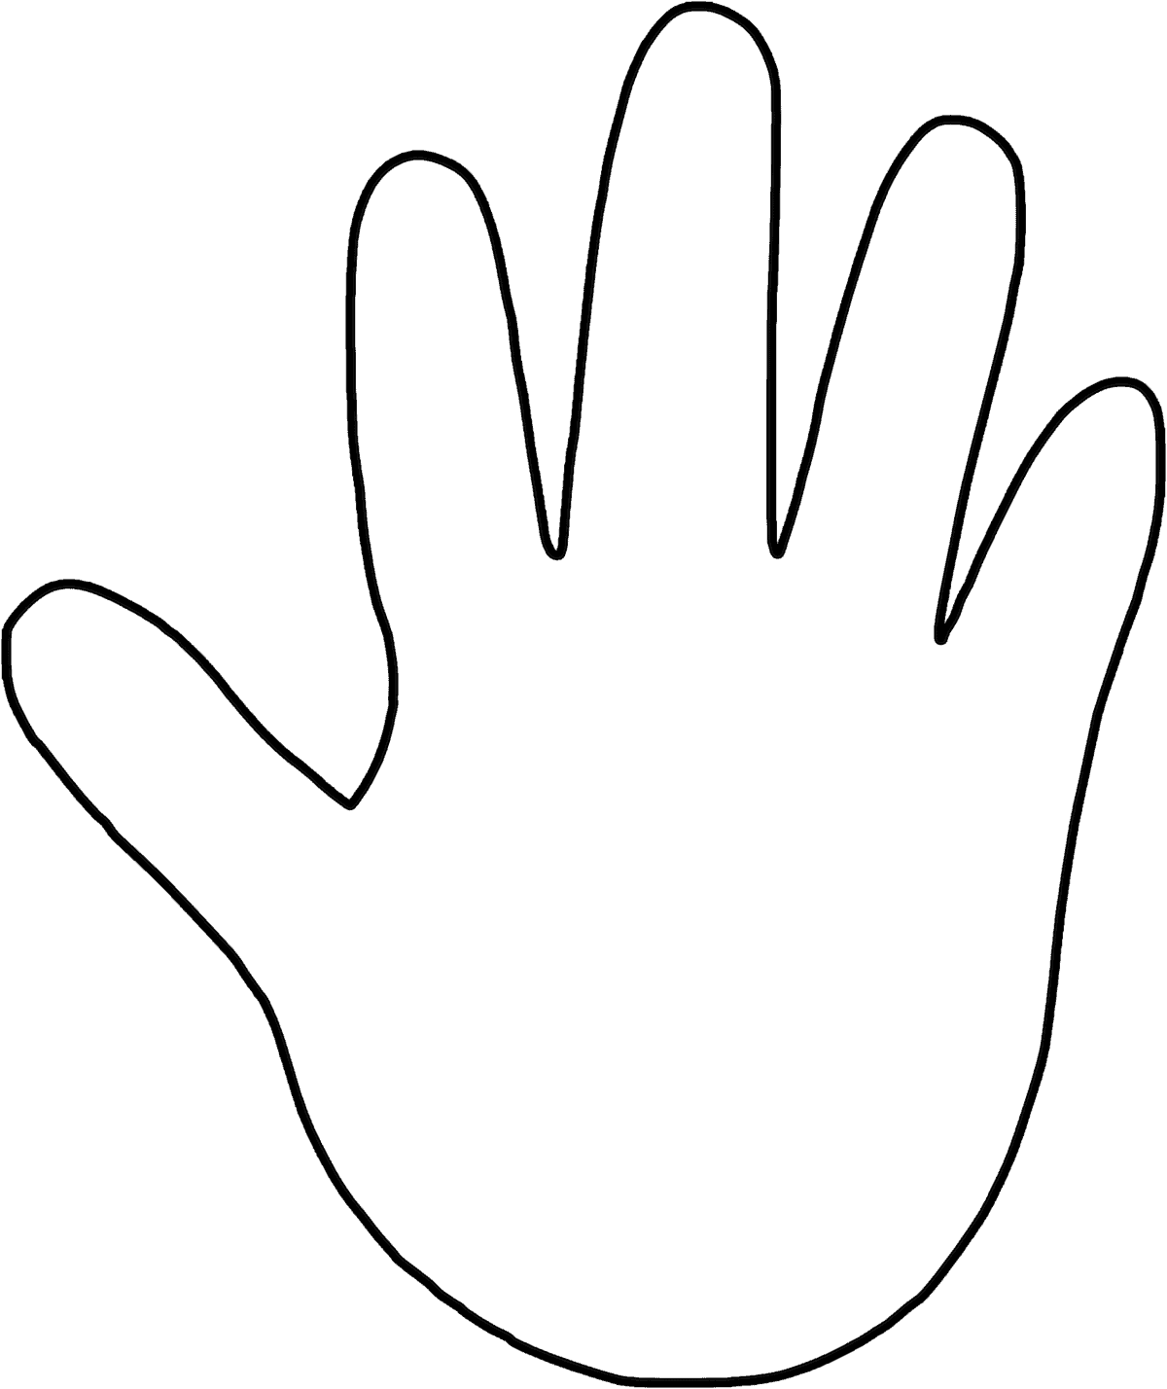

Other Rules:

* Have Fun!
* Try your hardest at every practice
* Stay off stairs, rock wall, or Mats unless directed otherwise
* No Roaming the halls.
* Follow Five finger Rule.

**Five Finger Pledge/Rule**

**Thumb: Positivity**- Encourage one another and promote positivity in the group.

**Index Finger:** Blaming- We do not point or blame others in the group

**Middle Finger:** Disrespect- There will be NO disrespect, we will listen and follow directions. Rudeness and disrespect bring nothing to our team and only acts as a disrupter.

**Ring Finger:** Commitment- Remember your commitment and your commitment to the team. If you are not having fun or if you do not want to do something keep in mind that someone else in the group may be loving the activity or dance.

**Pinky Finger:** Reminder- Everyone on the team is valuable and has worth.

**Reminder**

**Commitment**

**Positivity**

**Blaming**

**Disrespect**