**October 2017 Newsletter** 21034698_1596138977071927_3918624022801965162_n.jpg

**Class Fee’s:**

October Class fee’s are due on the 1st of every month. $10 late fee is applied after the 10th. Here are two options to pay for class fee’s.

1. **Automatic Payments: Setting up Auto Pay on your Dancers Account:**

Log into your dancers account at [www.justforkix.com/danceclasses](http://www.justforkix.com/danceclasses)

Click on "Make Payment/Classes" section

Under the column headed "Auto Pay" select the classes you want to set up auto pay for. You do not have to add anything to the cart.

1. **Log into your account every month to pay for the class fee’s**

Log into your dancers account at [www.justforkix.com/danceclasses](http://www.justforkix.com/danceclasses)

**Weekly Dress Code**

Come dressed ready to practice

**Hair:** Should be up in a ponytail or a bun for every practice

**Clothing:** Leggings, Shorts, t-shirt, tank top, leotard, or tights are acceptable

**Shoes:** Ballet Shoes, Jazz Shoes, or Socks

*No Jeans - No Jeans - No Jeans*

**Uniform Orders are Due**

Go to [justforkix.com/danceclasses](http://justforkix.com/danceclasses) log into your account to order your dancers uniform items.

The uniform is used only for performances, and the shoes are used for practices, and performances.

**What to Expect - October Classes**

**Classes 3yr - 3rd grade:** We will take a small break from working on our Winter Performance routine, and start working on a short fun Halloween Dance for the month of October. Dancers will be able to wear their Halloween Costume to class during the week of October 23rd - 29th.

**Classes 4th - 12th grade:** We will continue to work on and improving our technique, and skills, along with continuing to learn our Winter Performance routine for December. Dancers will be able to wear their Halloween Costume during the week of October 23rd - 29th.

**Custom Dance Apparel** 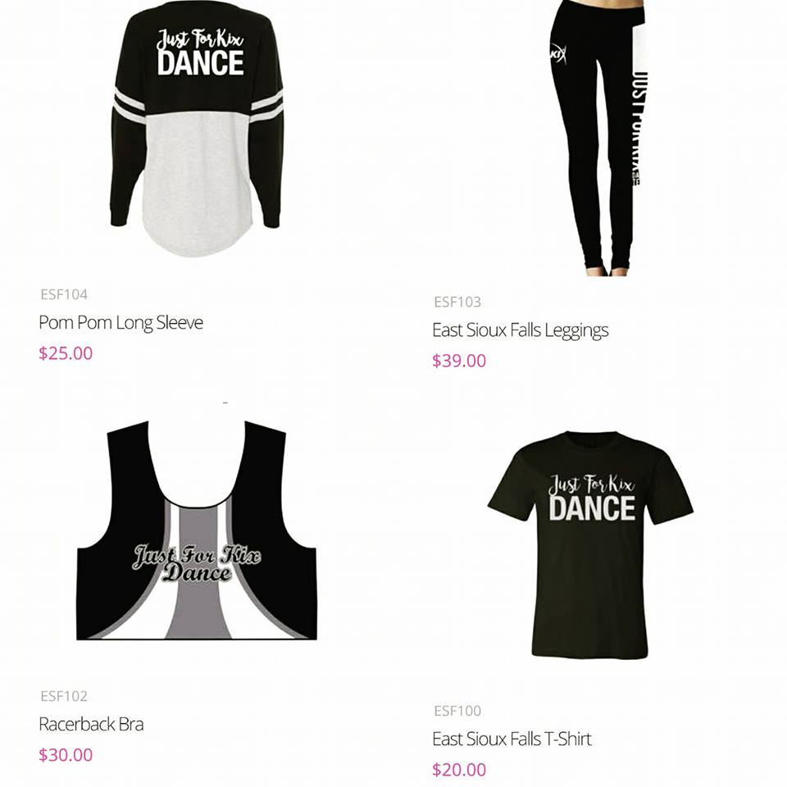

We have a few options this year for custom Just For Kix Dance Apparel. It's **NOT MANDATORY** to order any of the items, this is just additional option for your dancer to show off her love for Just For Kix! You can order your custom dance apparel online at <https://moveu.us/stores/eastsiouxfallsjfk>. **All orders are due on October 10th.** Items take 6-10 weeks to come in. Items will be arriving right before Christmas, this will make a great Christmas gift! Please let me know if you have any questions.

Important Dates (September - December)

|  |  |
| --- | --- |
| **October - Important Dates** | |
| October 23rd - 29th | Wear Your Halloween Costume To Class |
| October 31st - Tuesday | Happy Halloween! No Class |
| **November - Important Dates** | |
| November 22nd - Wednesday | Thanksgiving Break No Class |
| November 23rd - Thursday | Thanksgiving Break No Class |
| **December - Important Dates** | |
| December 16th | Winter Performance - USF Stewart Gym |
| December 17th - January 1st | Winter Break |
| **January - Important Dates** | |
| January 2nd | Spring Session Starts |

Meet the Staff 2017 - 2018

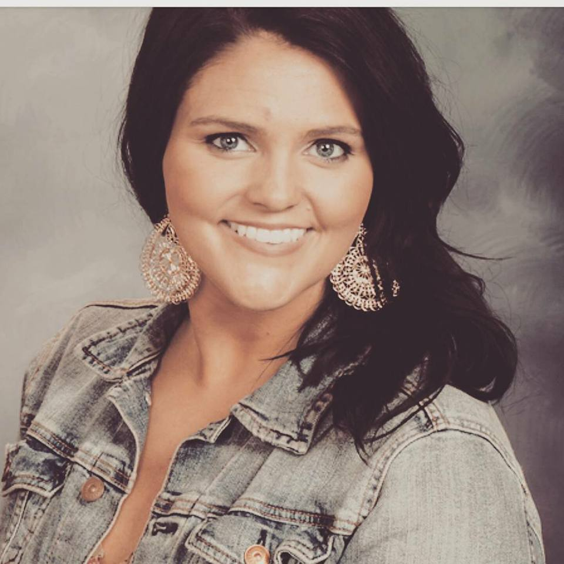

Hello! My name is Jennifer Anderson and I’m the Director of the Just For Kix Dance Program in East Sioux Falls & Crooks! I’m entering in my 5th year as Director. My career in dance started in 2008 instructing Ballet, Tap, Jazz, Hip Hop, Lyrical, and Kick for the past 9 years. The best part of my job is to see my students love for dance grow, and to watch them shine when they perform. My love for dance started at 3yr’s old, over the year’s I trained in Ballet, Pointe, Tap, Jazz, Lyrical, Modern, and Hip Hop.. I recently became engaged in May, and I’m looking forward to becoming the future Mrs. Jennifer Frankman! I love spending time outdoors with my family, and 8yr old Corgi Daisy. I’m looking forward to great year of dance!

My name is Sydney Bartunek and I'm an Assistant Coach for the Just For Kix dance programs. My dance experience began when I was five years old at Judi’s Dance Studio in Yankton, SD. I grew up training in Ballet, Pointe, Jazz, Lyrical, Dance Team, and Contemporary. Throughout high school, I taught several classes at the studio as well as participated in competitive cheerleading. While at the University of South Dakota, I was a member of the USD Dance Team and competed in NDA collegiate nationals. Thankfully dance is a passion that I continue to honor present day as a member of the LiRa Dance Theatre Company, and now as an instructor with the Just For Kix dance programs! I look forward to meeting you throughout the season!

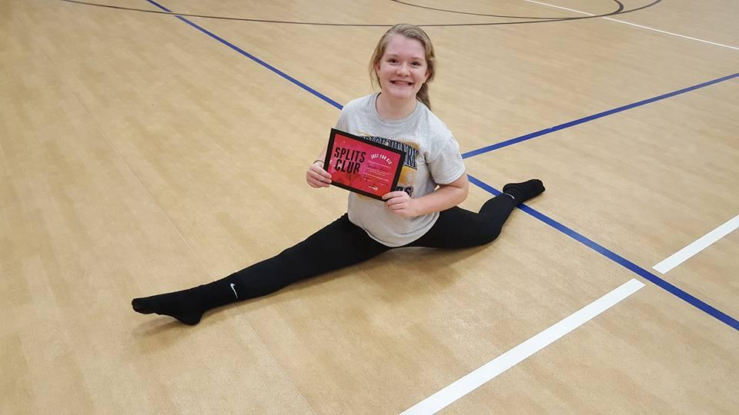

Hi! My name is Jenn Fitz. This will be my second year as an assistant dance instructor with Just For Kix East Sioux Falls. I am a Sophomore in High School and have been dancing with JFK for 5 years taking Kick, Hip Hop, Lyrical, Jazz, and a little Ballet. My favorite is Hip Hop because it is energetic with attitude. Dancing let's you be yourself which is one of the reasons I really enjoy dancing. You also build lifelong friendships. The reason I wanted to teach again this year is because I love to see the little kids grow as a dancer and feel confident in themselves.

17309070_1420132344672592_3146779638470676142_n.jpg

My name is kessa wolf. I've been dancing with just for kix for 4 years. I love assisting in dance classes and seeing the kids grow and mature in their dance moves. I continue to take classes in jazz, lyrical and kick! 

CONTACT INFORMATION

Jennifer Anderson

**\*\*Best way to reach me is via email**

Phone: 605-553-0028 (call or text)

Email: [eastsiouxfalls\_sd@justforkix.com](mailto:eastsiouxfalls_sd@justforkix.com) & [crooks\_sd@justforkix.com](mailto:crooks_sd@justforkix.com)

Website: [www.justforkix.com/danceclasses/east-sioux-falls-sd/](http://www.justforkix.com/danceclasses/east-sioux-falls-sd/)

JUST FOR KIX HOME OFFICE

JUST FOR KIX

7842 College Rd

Baxter MN, 56425

Phone: 218-829-7107