**February:**

Happy February!

Class time is very busy so if you are unable to connect with me at class, feel free to contact at the email lecenter_mn@justforkix.com and/or 952-388-8627

**Upcoming:**

2/1: Class Payment Due

2/8: STP Community Show (non-comp teams) - show starts @ 11

2/14: Starlite Kick begins, invite only (3rd-5th grade)

2/22: STP Competition (comp teams)

3/1: Class Payment Due

3/22: Sioux Falls Competition (comp teams)

[24/25 Important Dates](https://docs.google.com/document/d/1n-hI58Nn3WUxzAtVNiqYpffoaemyoAsWbc9r7cMq95U/edit?usp=sharing)

** There was a change in date for our nationals practice due to confirmation

**Stay informed:**

**E-MAIL**

Emails will be sent out on the 1st and 20th of every month - with upcoming details. Please make sure we have your most current e-mail address on file. If you have a spam blocker, e-mails from Just For Kix may be bounced back.

**WEBSITE**

justforkix.com/danceclasses - All emails and calendars sent out will also be posted on our Le Center Just For Kix website - [Website Link](https://justforkix.com/danceclasses/le-center-mn/)

**BAND APP**

Get current information fast with the BAND App. Announcements for bad weather, changes in plans, etc. It's easy to use.

**Community Show (St.Peter):**

**When:** 2/8 at 11:00 am - dancers arrive at 10:30 am, doors open at 10:15am

**Where:** 100 Lincoln Dr, St Peter, MN 56082 (at the middle school - different than last year)

**Who:** Tiny Kick, Wee Petite, Wee Kick

Please have your dancer arrive ready to go in their hair/make up and costume! When your dancer is done performing they will come and sit with you!

**TWD:**

Here is a link to 2024/2025 TWD Info! It answers common questions to competitions but if you can not find what you are looking for please shoot me an email or text and I would be happy to help ☺️

[TWD Info](https://docs.google.com/document/d/1DyDTb2MrlOivJzbfOkVXA-AcHkQEfc0lJUdu3rgq44A/edit?usp=sharing)

**St.Peter Competition:**

[Tentative Comp Schedule](https://docs.google.com/spreadsheets/d/15kUQj5Tcaa4pfYmP2pPYRwedoU-GCt1Z_0U55WZgDC8/edit?usp=sharing)

Comp fees have been added to your account - these fees need to be paid by 2/14

We are performing 2/22!

If you are not able to attend please let me know by 2/4 so I can be sure to drop the fees from your account! When the official schedule comes out I will send out official details!

I will keep updating the spreadsheet as we get schedule updates so you will always see the most current information.

**Sioux Falls:**

[Tentative Comp Schedule](https://docs.google.com/spreadsheets/d/1tw9tmr9Nk53RN_aJdYJ-pinUQuC-23SLNxwyHnUQiDo/edit?usp=sharing)

We are performing 3/22!

If you are not able to attend please let me know by 2/26 so I can be sure to drop the fees from your account! When the official schedule comes out I will send out official details!

I will keep updating the spreadsheet as we get schedule updates so you will always see the most current information.

**Marshall:**

[Tentative Comp Schedule](https://docs.google.com/spreadsheets/d/1UjddVXknJKn6mZSfFS4cctVRCIt_wjn4bOF7afPpI5o/edit?usp=sharing)

We are performing 4/5!

If you are not able to attend please let me know by 3/12 so I can be sure to drop the fees from your account! When the official schedule comes out I will send out official details!

I will keep updating the spreadsheet as we get schedule updates so you will always see the most current information.

**Band:**

I recently found out there is a BAND kids app - if your dancer has a device at home, they can join BAND too! Here are all of the links again:

[Tiny/Wee Petite Class Band](https://band.us/n/ada7A9J8J21cP)

[Wee Classes Band](https://band.us/n/a1a0AeJ6J02bq)

[Mini Classes Band](https://band.us/n/aca3AcJ0Jaz7C)

[Middle Classes Band](https://band.us/n/a5acA1JcJ6Y9B)

[SDS Band](https://band.us/n/a6aeA4J7JfzeW)

[Reliaquest Bowl](https://band.us/n/a7a0AfG4z2e9s)

**Program Eval:**

Below is the link for you to fill out a program evaluation. If you fill this out by Feb 14th to submit you’ll be entered for a chance to win the $50 gift cards to the TWD Store or Catalog for those that don't participate in TWDs! Your evals will help learn what’s working for our program and what’s not. My goal is to constantly be improving our program, so I love to hear your feedback.

[**https://www.surveymonkey.com/r/VYB8FPT**](https://www.surveymonkey.com/r/VYB8FPT)

**Nationals pins:**

New this year! Trading pins for dancers to trade with other programs at Nationals. This is not required but is such a fun way for our dancers to get to know other teams and fun collectors items!

[shop.justforkix.com/pages/pin-trading](https://shop.justforkix.com/pages/pin-trading?fbclid=IwZXh0bgNhZW0CMTAAAR077tUR3j8RETMMC8vFP1_2LS3qoR8GasjKwKvFbnwZQpU6szPhpaYtQVo_aem_td8373qhG75hCh0TXUblfA)

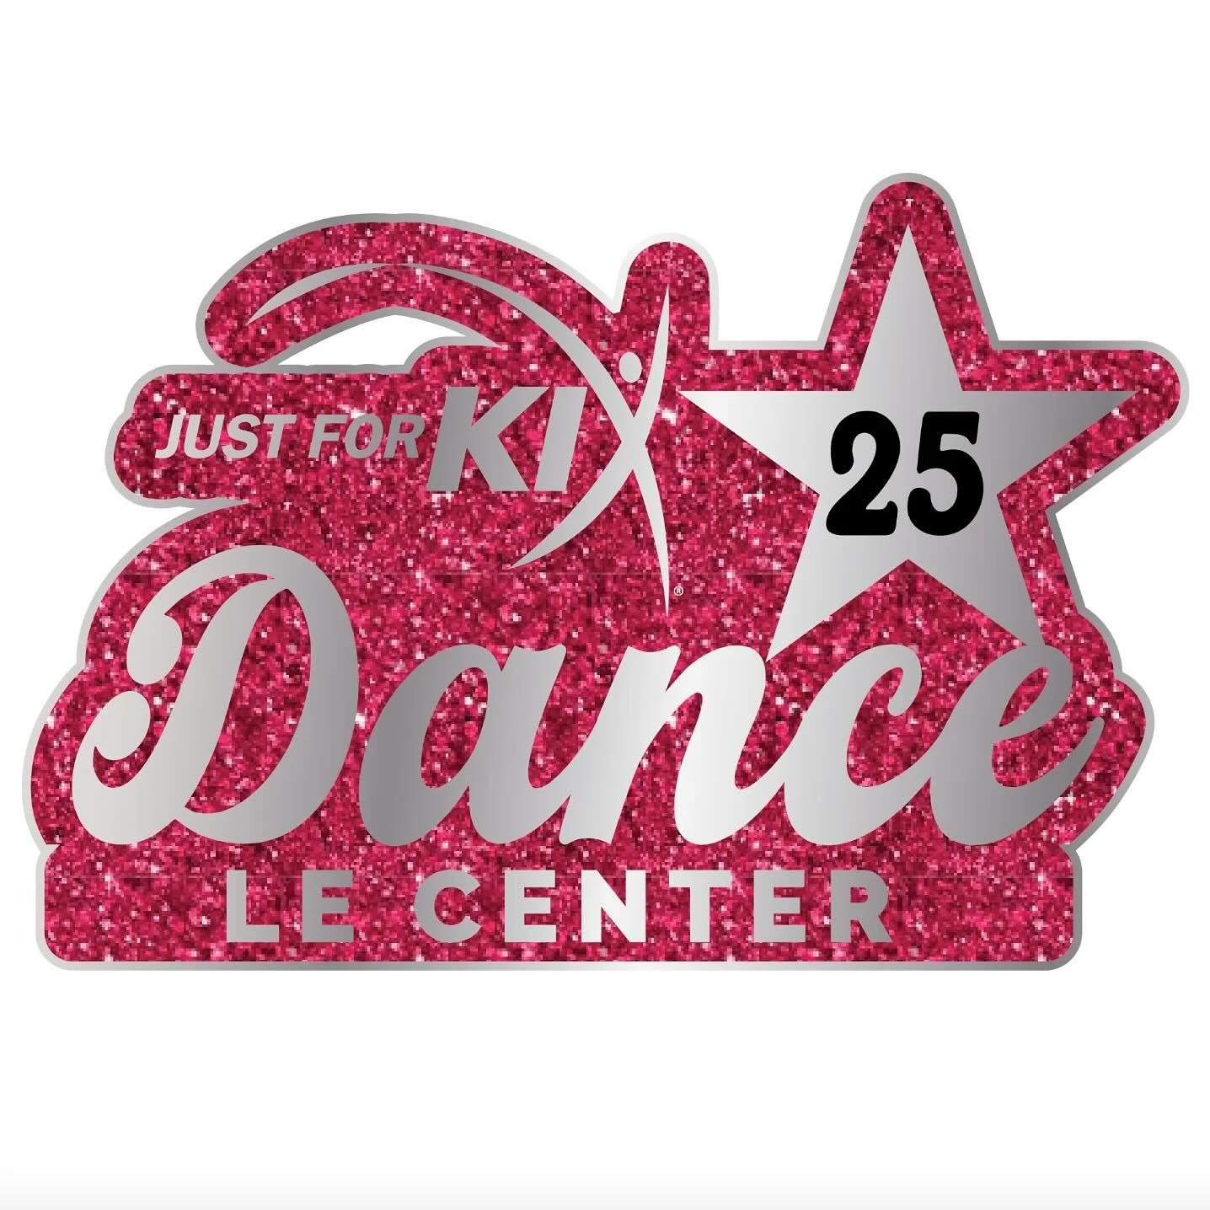

**February Calendar:**

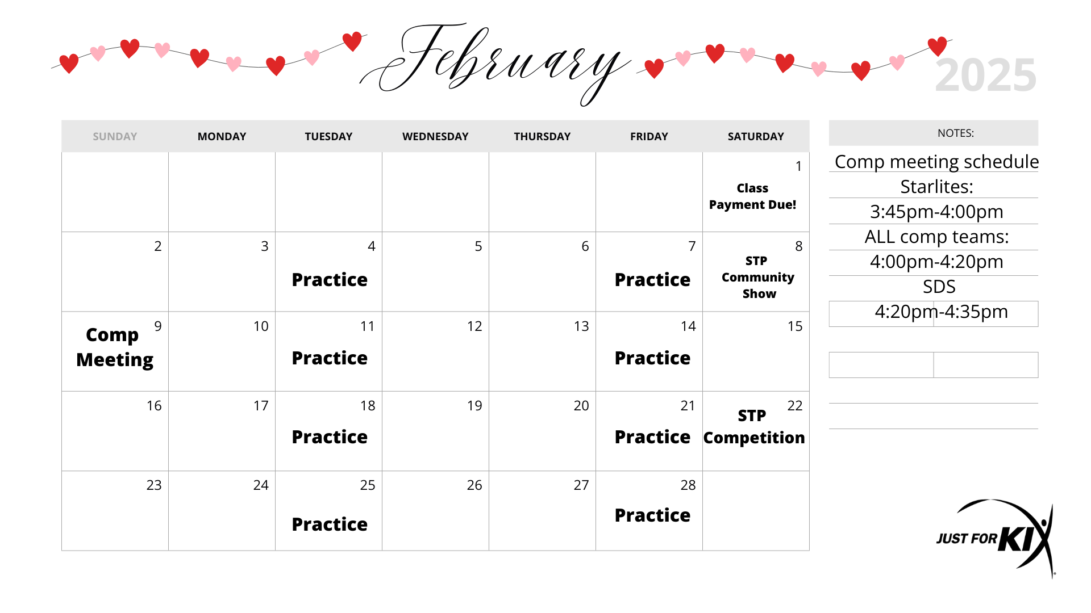

**March Calendar:**

