# MEMORY MATES **$15.00 +**Tax

*Dance in Blue, Pink or Red*



Individual Dancer Buttons **$7.00** +Tax

**$5.00** if you buy 2 or more

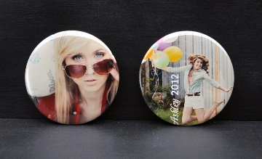

2018 Calendar **$8.00** +Tax

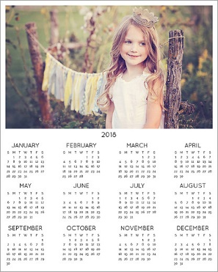

Flashlight Keychain **$8.00** +Tax

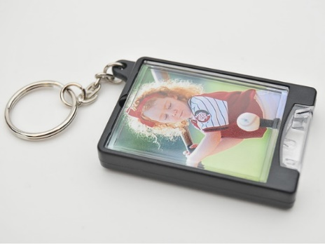

8x10 Prints **$10.00** +Tax

*Dance in Blue, Pink or Red*



*Black or White*



Metal Keychain Rings **$13.00** +Tax

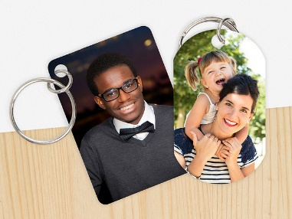

Photo Magnets **$5.00** +Tax

2x3.5” (2 per sheet) or 3x4.5”

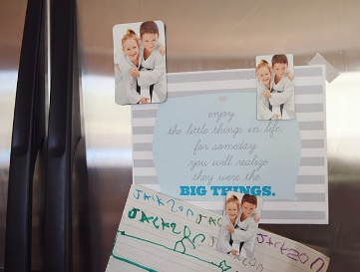

**Individual Pictures:**

8) Wallets: $3.20

4x6: $1.19

5X7: $3.49

8x10: $6.99

11x14: $14.99

**$35.00 Package:**

Memory Mate

8x10

(4) 4x6’s

(8) Wallets

(2) Buttons

**$45.00 Package:**

Memory Mate

8x10 (Fancy Design)

(2) 5x10’s

(4) 4x6’s

(8) Wallets

(2) Buttons