MEMORY MATES $15.00 (Includes Team Photo)
Dance in Blue, Pink or Red
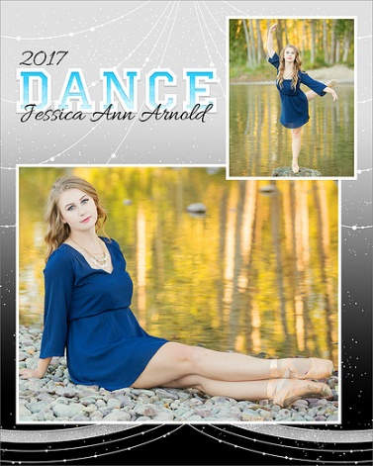
8x10 Prints $10.00
Dance in Blue, Pink or Red


